**Order Line Inquiry:** The Order Line Inquiry tab allows you to search for particular order lines to view their current statuses based on the information those lines might contain. It’s possible for a line to have more than one result entry, based on how CNH handled the order line, as you can only make an inquiry for order lines that have been **submitted**. It’s also possible for there to be error or warning messages on the lines, again due to CNH finding something while processing the order.

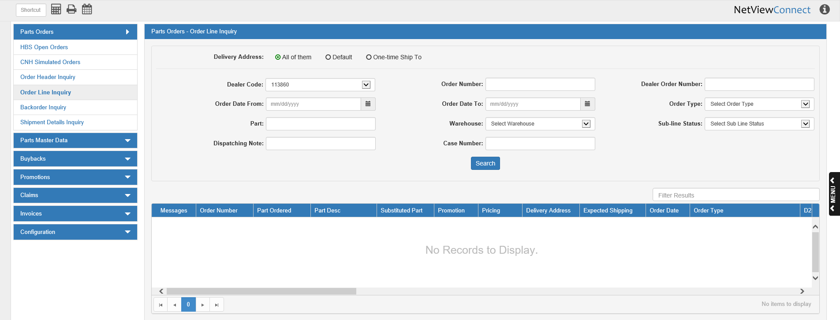

**Search Filter Fields:**

Delivery Address: Select what type of delivery address assigned to orders that you want to search by:

* Dealer’s default address (Default)
* One-time shipping address (OTS)
* All of them—**default** selection

Dealer Code: Select a dealer code to search by. This applies most to dealerships that have more than one CNH code, and so could have attached different codes to different orders.

Order Number: To search for lines by the CNH-assigned order number, enter the number here.

Dealer Order Number: To search for lines by the dealer-assigned order number, enter the number here.

Order Date From/To: To search for lines by a range of order dates, enter the starting and ending dates of the range in these fields or select them using a calendar. To search for a single order date, enter the date in both fields.

Order Type: To search for lines by the order type, select the type here, then set a date range using the Order Date From/To fields. You are **required** to use a date range when searching by Order Type.

Part: To search for lines by their part number, enter the number here.

Warehouse: To search for lines by their assigned warehouse, select the warehouse here. **NOTE:** Make sure you have loaded the warehouse codes from CNH so this option works properly.

Sub-line Status: To search for lines by their individual line status, select the status code here, then set a date range using the Order Date From/To fields. You are **required** to use a date range when searching by Sub-line Status.

Dispatching Note: To search for lines by their dispatching note, enter the note text here.

Case Number: To search for lines by their case number, enter the number here.

**Search:** After you have set at least 1 filter (besides the Delivery Address), click this button to begin the search. The Results grid below will populate with order lines that match the search criteria.

You can use the scroll bars at the bottom and side to view all the entries and their many columns, as well as using the column headers to sort the results in different orders. You can also adjust the column widths in order to view more of them at once without resorting to the scroll bar (though there are limits to how large or small they can grow).

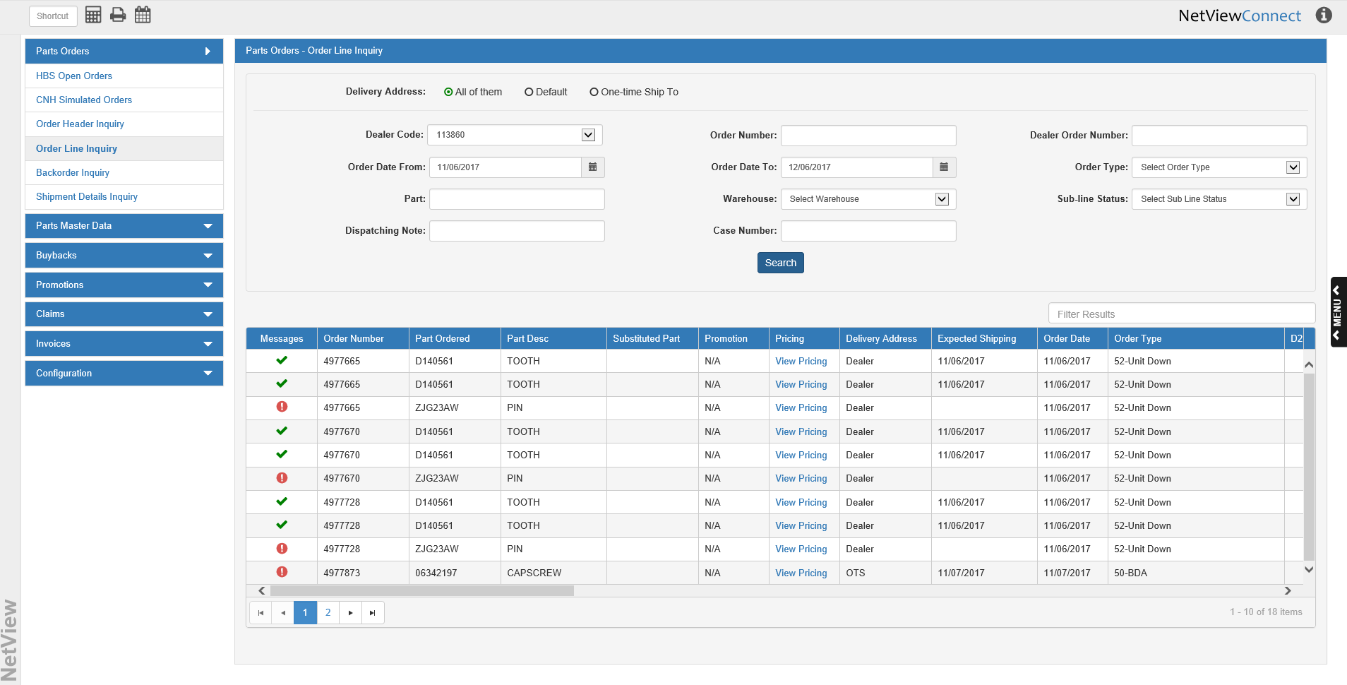

**Filter Results:** Use this field to filter your results by entering specific information.

**Grid Columns:**

Messages: Each line will show either a , a , or a  icon in this column. The  icon means that the line has no errors, and thus no messages. The  or  icon means there is a message on the line. Click the icon to view the message details in a separate window (see below image).

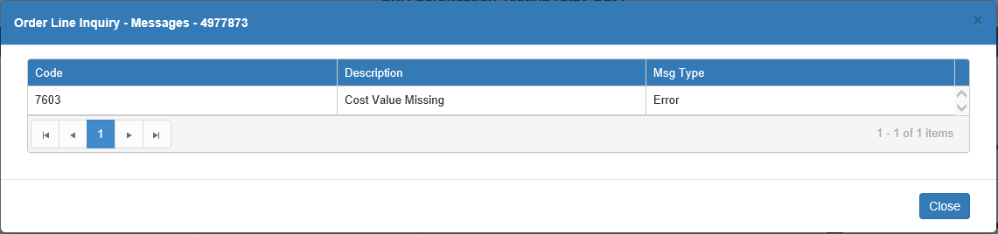

**Code:** This column shows the message code.

**Description:** This column contains the actual message.

**Msg Type:** This column shows the message type, which will be either “Warning” or “Error.”

Order Number: This column shows the CNH-assigned order number for the line.

Part Ordered: This column shows the part number ordered for that line.

Part Desc: This column shows the part’s description.

Substituted Part: If the originally ordered part has been substituted with another part, the substitution part number appears here.

Promotion: If the line is eligible for a promotion, then the words “View Promo” will appear in this column. Click on the words to view the promo details.

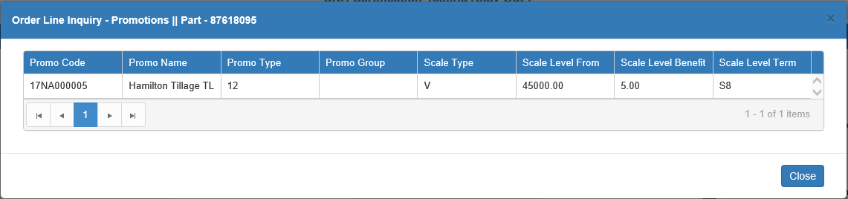

**Promo Code:** This column shows the promo code.

**Promo Name:** This column shows the promo name.

**Promo Type:** This column shows the promo type.

**Promo Group:** This column shows the promo group, if applicable.

**Scale Type:** This column shows the promotion’s scale type.

**Scale Level From:** This column shows the minimum quantity or dollar amount required on the line in order for it to be eligible for a scale level of the promotion.

**Scale Level Benefit:** This column shows the promotional benefit, either the discount percentage or promotional price, offered by this scale level.

**Scale Level Term:** This column shows the eligible promotional payment term code, if applicable to the scale level.

Pricing: This column will show the words “View Pricing.” Click them to view the order line’s pricing details.

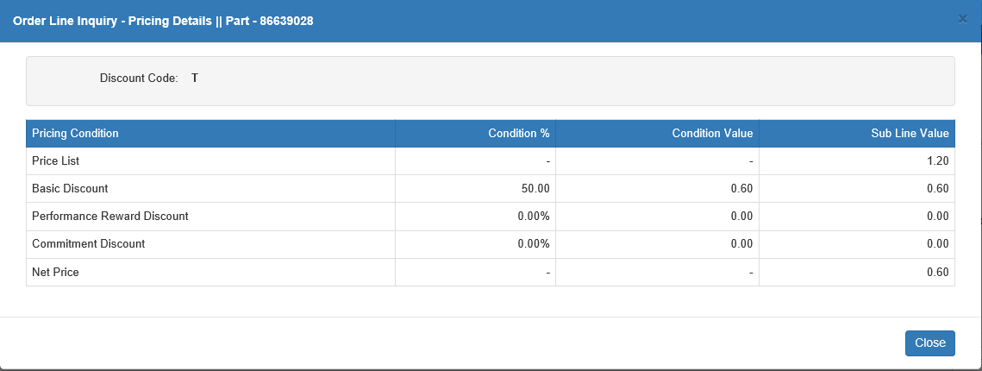

**Discount Code:** This field shows the line’s discount code.

**Grid Columns:**

* **Pricing Condition:** This column lists the pricing conditions which affect the line (list price, discounts, net price, etc.).
* **Condition:** This column shows the percentage represented by the condition which can be used either discount or increase the part’s price.
* **Condition Value:** This column shows the actual dollar value of the condition, which is determined by applying the condition percentage to the part’s list price.
* **Sub line Value:** This column shows a running total of the subline cost based on the condition values being applied to it. The net price is the final calculated unit price for the line.

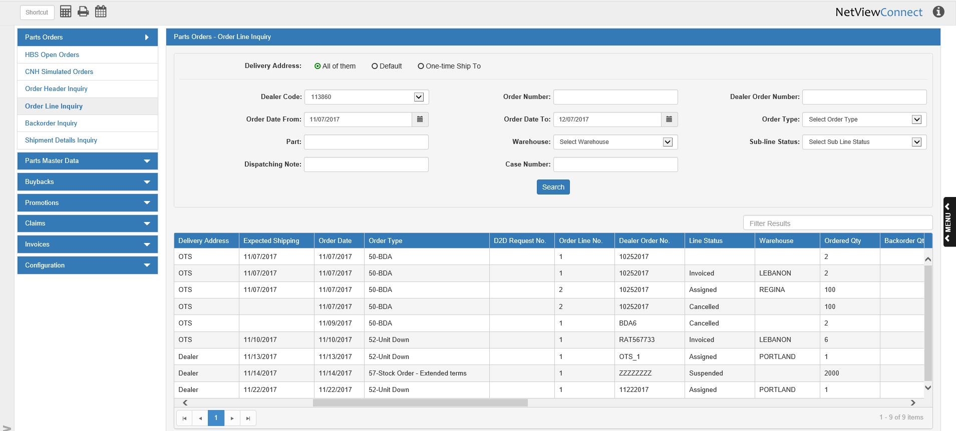

Delivery Address: This column shows whether the order line’s parts will ship to the dealer’s default (Dealer) address or a one-time shipping (OTS) address.

Expected Shipping: This column shows the order line’s expected shipping date.

Order Date: This column shows the order’s creation date for the line.

Order Type: This column shows the order type for the line.

D2D Request No.: This column shows the Dealer 2 Dealer (D2D) Request number, if applicable.

Order Line No.: This column shows the number of the order line. It is possible for the same order line number to be split between multiple grid entries, depending on how CNH handled the line.

Dealer Order No.: This column shows the dealer-assigned order number.

Line Status: This column shows the line’s current processing status (Assigned, Cancelled, Invoiced, etc.). The status also indicates which of the Quantity columns (see below for more information) will actually hold the quantity value for the grid entry line. For example, if the status is Cancelled, the quantity will be listed in the Cancelled Qty column.

Note that a single line can have more than one status depending on how CNH has divided the line’s part quantity, which will appear as separate entries on the grid. For example, if you have ordered 100 units of a part, but CNH has cancelled 50 units of your order while assigning the other 50, then your order line’s inquiry information will be divided into 2 grid lines: one line with a Cancelled status that shows 50 in the Cancelled Qty column, and one line with an Assigned status that shows 50 in the Assigned Qty column.

Warehouse: This column shows the warehouse for the line’s parts. Note that it’s possible for one order line to have multiple warehouses assigned, depending on how CNH handled the line, which can split the line into multiple entries on the grid.

Ordered Qty: This column shows the quantity of the line’s part that was originally ordered.

Backorder Qty: This column shows the part quantity on the line that needs to be backordered.

Confirmed Qty: This column shows the part quantity currently confirmed for the order line by CNH.

Reserved Qty: This column shows the part quantity currently reserved for the order line by CNH.

Assigned Qty: This column shows the part quantity currently assigned to the order line by CNH.

Packed Qty: This column shows the line’s part quantity currently packed for shipping.

Dispatched Qty: This column shows the part quantity for the line that has currently been shipped.

Invoiced Qty: This column shows the part quantity for the line that has currently been invoiced.

Deferred Qty: This column shows the part quantity for the line that CNH has deferred. **NOTE:** CNH dealers in the U.S. and Canada will never have a quantity in this column, as all orders in North America are immediate.

Cancelled Qty: This column shows the part quantity of the line that CNH cancelled, i.e. that will not be delivered.

Suspended Qty: This column shows the part quantity of the line that CNH has suspended for delivery.

Bin Location: This column shows the bin location for the line’s part.

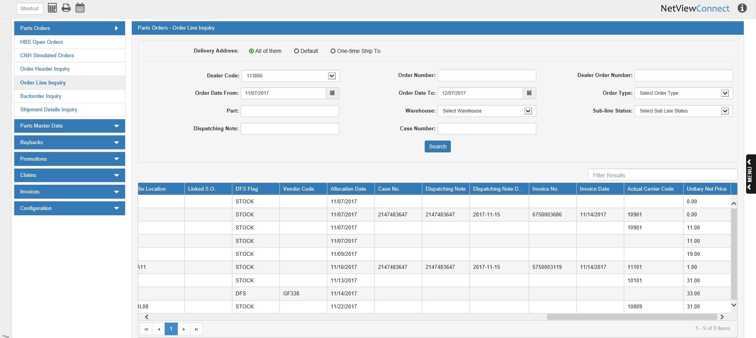

Linked S.O.: This column shows the linked S.O. for the line, if applicable.

DFS Flag: This column shows the DFS flag for the line’s part.

Vendor Code: This column shows the vendor code for the line, if applicable.

Allocation Date: This column shows the order line’s allocation date.

Case No.: This column shows the case number for the line, if applicable.

Dispatching Note: This column shows the dispatching note for the line, if applicable.

Dispatching Note Date: This column shows the dispatching note date for the line, if applicable.

Invoice No.: This column shows the line’s invoice number, if applicable.

Invoice Date: This column shows the line’s invoice date, if applicable.

Actual Carrier Code: This column shows the actual carrier code for the line, if applicable.

Unitary Net Price: This column shows the unitary net price of the line’s part, i.e. the net price of a single part unit.